CA-3

1. Data items A and B are initialized to zero in the following transactions:

T1: read (A) ;

read (B) ;

if A= 0 then B : = B + 1 ;

write (B) ;

T2: read (Q) ;

read (A) ;

if B = 0 then B : = B + 1 ;

write (A) ;

Any non-serial interleaving of T1 and T2 for concurrent execution leads to______

A. serializable schedule

**B. schedule that is not conflict serializable**

C. conflict serializable schedule

D. schedule for which a precedence graph cannot be drawn

Solution: <https://www.geeksforgeeks.org/database-management-system-set-3>

2. Which concurrency control protocols ensure both conflict serializability and freedom from deadlock?

i. 2-phase locking

ii. Time-stamp ordering

A. i only

**B. ii only**

C. Both i and ii

D. Neither i nor ii

3. Consider the following schedule S of transactions T1, T2, T3, T4:

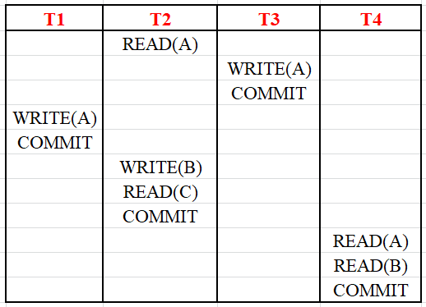

Which one of the following statements is CORRECT?

A. S is conflict-serializable but not recoverable

B. S is not conflict-serializable but is recoverable

**C. S is both conflict-serializable and recoverable**

D. S is neither conflict-serializable nor is it recoverable

4. Which of the following statement is/are CORRECT?

i. A schedule following strict two phase locking protocol is conflict serializable as well as recoverable.

ii. Checkpoint in schedules are inserted to ensure recoverability.

**A. Only 1**

B. Only 2

C. Both 1 and 2

D. None

5. Consider that transaction Ti requests a lock which is held by transaction Tj. The following table concludes the actions taken for WAIT-DIE and WOUND-WAIT scheme:

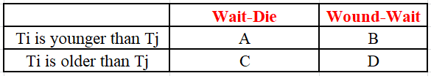

Fill correct status of Ti and Tj at A, B, C & D respectively.

A. Ti dies, Ti waits, Ti waits, and Tj aborts respectively.

**B. Ti dies, Ti waits, Ti waits, and Tj aborts respectively.**

C. Ti waits, Ti dies, Ti waits, and Tj aborts respectively.

D. Ti waits, Ti dies, Ti aborts and Tj aborts respectively

Solution: <https://www.geeksforgeeks.org/dbms-gq/transactions-and-concurrency-control-gq/>

6. In transaction management, which of the following has the highest isolation level?

**A. Serializable**

B. Repeated Read

C. Committed Read

D. Uncommitted Read

7. Match the following:

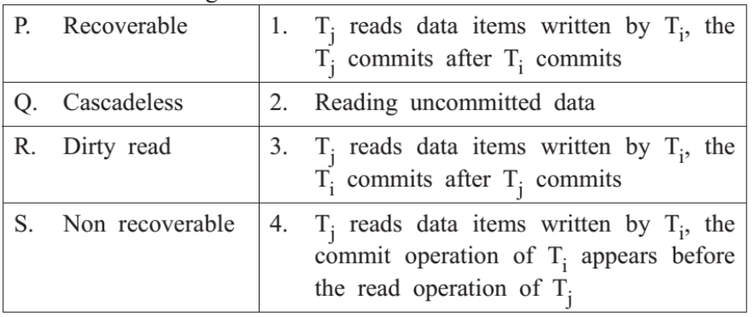

a. P-2, Q-1, R-4, S-3

b. P-2, Q-3, R-4, S-1

c. P-3, Q-4, R-2, S-1

**d. P-1, Q-4, R-2, S-3**

8. In the following transactions, which of the given below are conflicting?

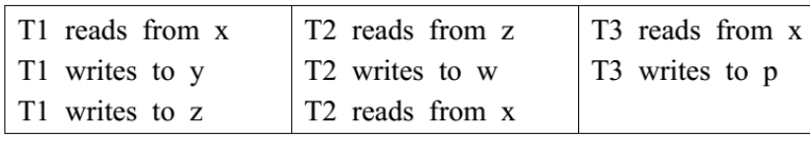

a. T1 & T2, T1 & T3

b. T1, T2 & T3

c. T1 & T3, T2 & T3

**d. T1 & T2**

9. Which option is correct as far as Two phase commit protocol is concerned?

**A. Ensures serializability**

B. Prevents Deadlock

C. Detects Deadlock

D. Recover from Deadlock

10. Let us assume that transaction T1 has arrived before transaction T2. Consider the schedule

S = R1(X); R2(Y) ; W2(X); W1(Y)

Which of the following is true?

A. Allowed under basic timestamp protocol.

**B. Not allowed under basic timestamp protocols because T1 is rolled back**

C. Not allowed under basic timestamp protocols because T2 is rolled back

D. Allowed in all possible scenarios

11. The following diagram depicts the states in the transaction. Which of the following options correctly fill the spaces 1, 2 and 3 respectively?

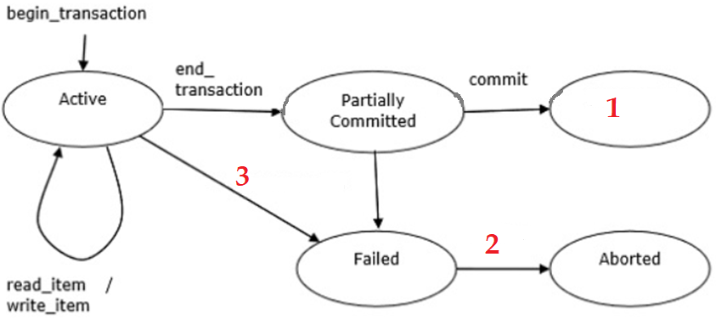

a. **Committed, Rollback, Unsuccessful**

b. Rollback, Committed, Unsuccessful

c. Rollback, Unsuccessful, Committed

d. Committed, Unsuccessful, Rollback

12. Which problem is reflected by the below schedule?

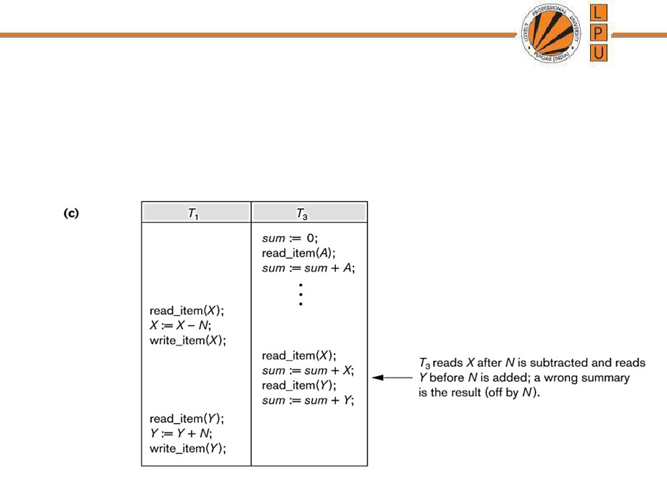

a. Uncommitted Data Problem

**B. Incorrect Summary Problem**

c. Lost Update Problem

d. Dirty Read Problem

13. Whenever a Transaction T issues a R_item(X) operation, 2 conditions are checked while using Basic Timestamp Ordering. From the following options, select the right two conditions?

a. **When W_TS(X) > TS(T), then abort and reject T and reject the operation and rollback.**

**When W_TS(X) <= TS(T), then execute the R_item(X) operation of T and set R_TS(X) to the maximum of TS(T).**

b. When W_TS(X) < TS(T), then abort and reject T and reject the operation and rollback.

When W_TS(X) <= TS(T), then execute the R_item(X) operation of T and set R_TS(X) to the maximum of TS(T).

c. When W_TS(X) > TS(T), then abort and reject T and reject the operation and rollback.

When W_TS(X) >= TS(T), then execute the R_item(X) operation of T and set R_TS(X) to the maximum of TS(T).

d. When W_TS(X) < TS(T), then abort and reject T and reject the operation and rollback.

When W_TS(X) >= TS(T), then execute the R_item(X) operation of T and set R_TS(X) to the maximum of TS(T).

14. _________ log record describes a single database write and has the following fields depicted as : < Ti, Xj, V1,V2 >

a. <Start>

**b. <Update>**

c. <Commit>

d. <Abort>

15. Consider the two schedules as shown below. What can you analyze about S1 and S2?

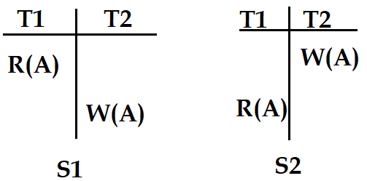

**a. S1 ≠ S2**

b. S1 = S2

c. S1 > S2

d. S1 < S2

16. When no read operation is performed before writing any value then it known as _____ .

a. Closed Write

**b. Blind Write**

c. Blinder Write

d. End Write

17. In which if the following phase, the system replays updates of all transactions by scanning the log forward from the last checkpoint.

a) Repeating

**b) Redo**

c) Replay

d) Undo

18. PL/SQL block consists of:

i. Declare

ii. Begin

iii. Exception

iv. End

Which of the given above section(s) is/are completely optional?

a. Declare and end

**b. Declare and Exception**

c. Begin and Exception

d. Begin and Declare

19. If you are asked to write PL/SQL code to print numbers from 1-n, some of the task has been done for you. Complete the missing statements.

DECLARE

a NUMBER := 1;

n NUMBER;

BEGIN

n := :n;

LOOP

(a)___________

(b)___________

EXIT WHEN a > n;

END LOOP;

END;

**a. DBMS_OUTPUT.PUT_LINE(a);**

**a := a+1;**

b. DBMS_OUTPUT.PUT_LINE(n);

n := n+1;

c. DBMS_OUTPUT.PUT_LINE(a);

a := a-1;

d. DBMS_OUTPUT.PUT_LINE(a);

a := +1;

20. RAISE_APPLICATION_ERROR is a built-in procedure in oracle which is used to display the user-defined error messages along with the error number. The syntax for the same is:

a. RAISE_APPLICATION_ERROR (error_message);

**b. RAISE_APPLICATION_ERROR (error_number, error_message);**

c. RAISE_APPLICATION_ERROR (error_number);

d. RAISE_APPLICATION_ERROR ();

21. If a SELECT statement attempts to retrieve data based on its conditions, but instead an exception is raised when no rows satisfy the SELECT criteria. Which exception will be raised?

a. TOO_MANY_ROWS

**b. NO_DATA_FOUND**

c. VALUE_ERROR

d. DUP_VAL_ON_INDEX

22. Which attribute is TRUE when a cursor has some remaining rows to fetch, and FALSE when a cursor has no rows left to fetch?

a. %ROWCOUNT

**b. %FOUND**

c. %FIND

d. %ISOPEN

23. Consider the given Total_Bill table:

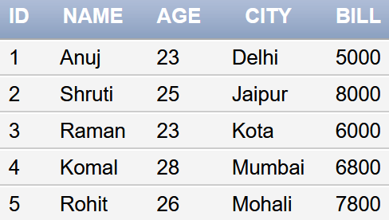

Below is the PL/SQL block to count the number of rows affected by an update statement on the above table. Fill in the incomplete lines of the code

DECLARE

rows NUMBER;

BEGIN

UPDATE Total_Bill SET Bill = Bill + 1000;

IF (1)______ THEN

DBMS_OUTPUT.PUT_LINE('NO CUSTOMER SELECTED...');

ELSIF (2)_____ THEN

rows := (3)________;

DBMS_OUTPUT.PUT_LINE(rows ||' rows has been selected...');

END IF;

END;

a. (1) sql%found, (2) sql%notfound, (3) sql%rowcount

**b. (1) sql%notfound, (2) sql%found, (3) sql%rowcount**

c. (1) sql%found, (2) sql%rowcount, (3) sql%notfound

d. (1) sql%notfound, (2) sql%rowcount, (3) sql%found

24. How many ELSE clauses can be included in an IF clause that is not nested?

**a. 1**

b. 0

c. maximum 4

d. Any number

25. Pragmas are processed at ___________ .

i. Run time

ii. Compile time

a. Only i

**b. Only ii**

c. Both i and ii

d. It is not processed

26. What is the advantage of using the %ROWTYPE datatype?

i. It is useful to retrieve an entire row from a table. If you do not use the %ROWTYPE datatype, then you have to declare variables for each column separately.

ii. It can be used even if data type of the table columns is not known.

iii. It ensures that data type of the variable changes dynamically if the underlying table is altered.

a. Only i & ii

b. Only iii

c. Only ii

**d. Only i, ii & iii**

27. Which of the following is not true about PL/SQL constants and literals?

A. A CONSTANT declaration requires an initial value.

B. A constant is declared using the CONSTANT keyword.

**C. The CONSTANT declaration cannot impose the NOT NULL constraint.**

D. A constant holds a value that once declared, does not change in the program.

28. Which of the following code will open a cursor named C123?

A. FETCH C123;

**B. OPEN C123;**

C. OPEN CURSOR C123;

D. OPENED C123;

29. Which of the following would cause an infinite loop to occur in a simple loop if left out?

A. LOOP

**B. END LOOP**

C. IF-THEN

D. EXIT

30. List the correct sequence of commands to process a set of records when using explicit cursors

A. INITIALIZE, GET, CLOSE

B. CURSOR, GET, FETCH, CLOSE

**C. OPEN, FETCH, CLOSE**

D. CURSOR, FETCH, CLOSE